**Common Interview Questions and Answers**

As you prepare for your interview, you may be considering which questions the employer is going to ask you. While there’s no way to know for sure what topics will be covered, there are several types of popular interview questions you can expect to be asked and, therefore, be prepared to discuss.

Every interviewer is different and their exact questions may vary. By preparing answers for these common interview questions, you can develop compelling talking points to [make a great impression](https://www.indeed.com/career-advice/interviewing/job-interview-tips-how-to-make-a-great-impression) during your next job interview.  
In this article, we share some of the most commonly asked interview questions with tips on what interviewers are looking for in your response and example answers.

### 1. Tell me about yourself

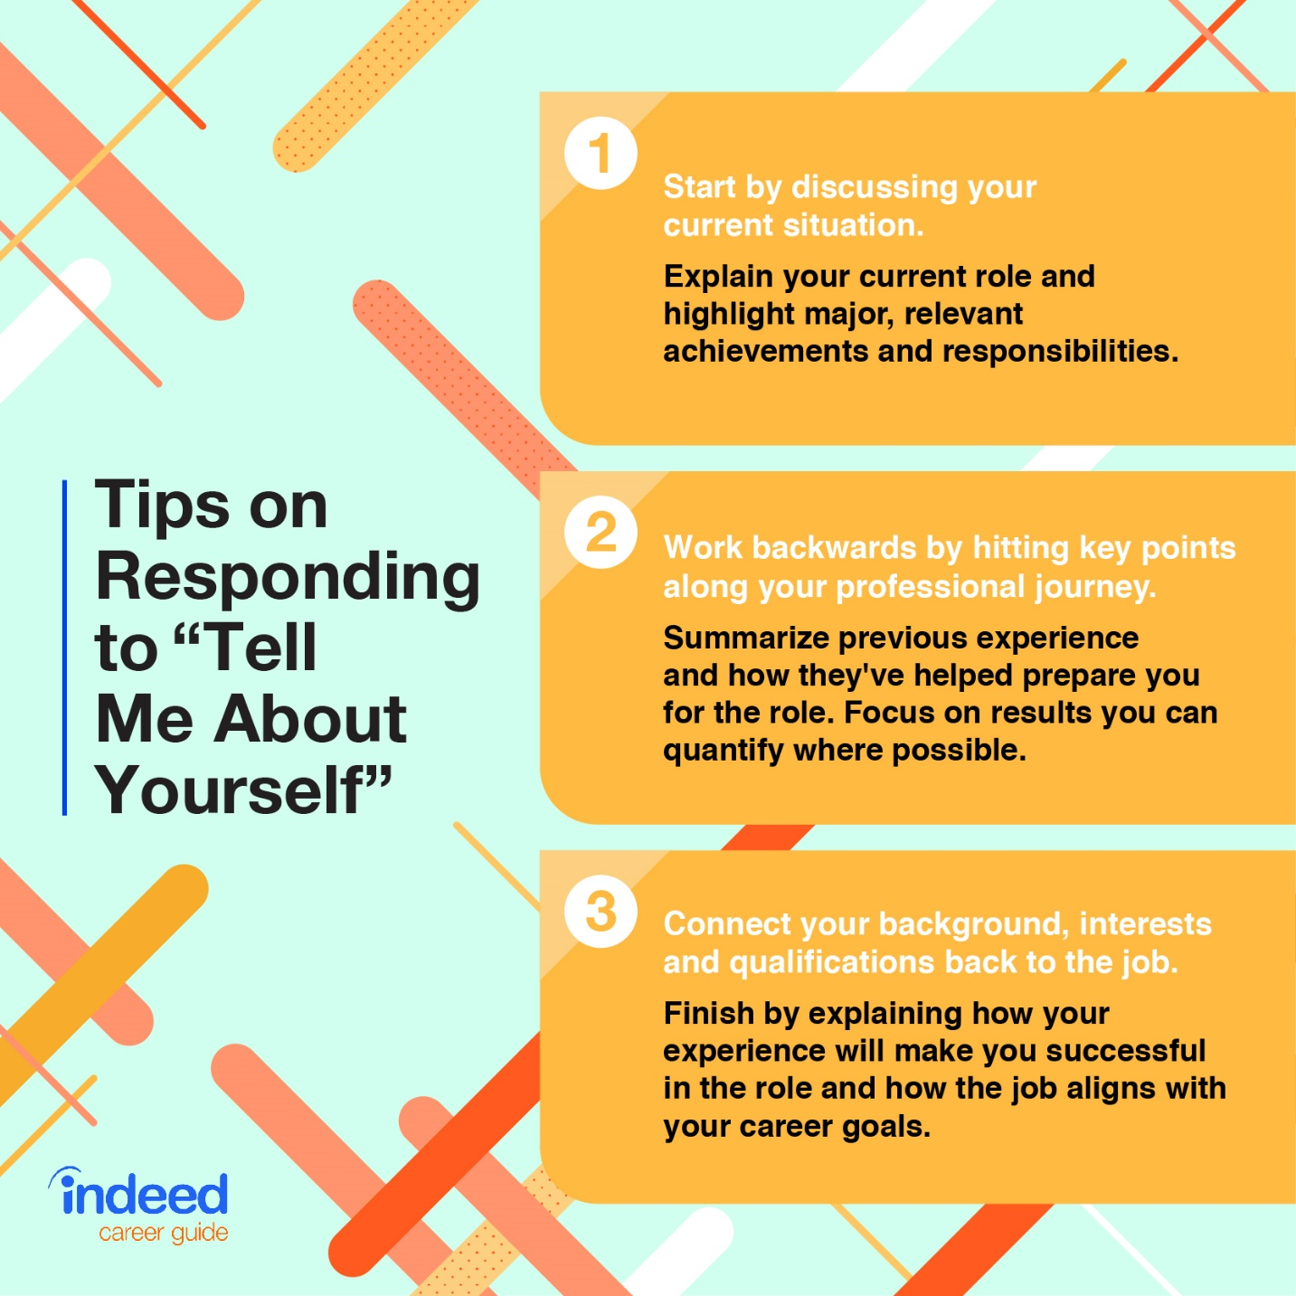

### 2. How would you describe yourself?

With this question, your interviewer wants to learn how your qualities and characteristics align with the skills they believe are required to succeed in the role. To answer this question, pick one to a few personal characteristics and elaborate on them with examples.

For example, if you are ambitious and driven you can say:  
“I am an ambitious and driven individual. I thrive in a goal-oriented environment where I can constantly challenge myself personally and professionally. I am always looking for an opportunity to do better and grow. These characteristics have helped me achieve success in my career. For example, I was promoted three times in less than two years in my last position.”

### 3. What makes you unique?

Employers often ask this question to identify why you might be more qualified than other candidates they’re interviewing. To answer, focus on why hiring you would benefit the employer. Since you don’t know the other applicants, it can be challenging to think about your answer in relation to them. Addressing why your background makes you a good fit lets employers know why your traits and qualifications make you a strong candidate.

To help you prepare this answer consider the following:

* **Assets the employers finds valuable:** Review the job description for role responsibilities as well as required and desired skills, qualities, experience and qualifications. For example, if a position emphasizes cross-collaboration, you might speak about your ability to unite a team around a common goal.
* **Ways you've been successful in previous roles:** Reflect on past accomplishments and list the qualities that helped you achieve them. For example, if you received an award for your marketing skills you might share this along with the project or experience that earned you the award.
* **Traits or skills you've been praised for:** Consider your strengths and qualities commonly recognized by previous employers or coworkers. Think back to positive feedback you’ve received from performance reviews and completed projects. For example, if your employer consistently brings up your ability to motivate others in your performance reviews, it’s likely a trait they highly value and other employers would also appreciate.

**Example answer:** "What makes me unique is my ability to meet and exceed deadlines. In my previous role, my manager consistently praised me for completing my projects efficiently with a high level of quality. This allowed me to take on additional responsibilities and eventually led to a promotion."

### 4. Why do you want to work here?

Interviewers often ask this question to determine whether or not you took the time to research the company and think critically about whether you’re a good fit. The best way to prepare for this question is to do your homework and learn about the products, services, mission, history and culture of this workplace. In your answer, mention the aspects of the company that appeals to you and aligns with your values and career goals.

**Example answer:** “The company’s mission to help college grads pay off their student loan debt resonates with me. I’ve been in student loan debt myself and would love the opportunity to work with a company that’s making a difference. Finding a company with a positive work environment and values that align with my own has remained a priority throughout my job search and this company ranks at the top of the list.”

### 5. What interests you about this role?

Hiring managers often ask this question to ensure you understand the role and give you an opportunity to highlight your relevant skills. Study the job description carefully and compare its requirements to your skills and experience. Choose a few responsibilities you particularly enjoy or excel at and focus on those in your answer.

**Example answer:** “While I highly valued my time at my previous company, there are no longer opportunities for growth that align with my career goals. This position fits perfectly with my skill set and how I’m looking to grow in my career. I’m also looking for a position at a company like yours that supports underserved communities, which is a personal passion of mine.”

### 6. What motivates you?

Employers ask this question to gauge your level of self-awareness and ensure your sources of motivation align with the role and company. To answer, be as specific as possible, provide real-life examples and tie your answer back to the job role and/or the company’s mission

Consider asking yourself these questions to prepare your answer:

* What did a great day at work look like in your previous role and why?
* What made you choose your profession or field?
* What prompted you to apply for the role when you read the job description?

**Example answer:** “Making a true difference in the lives of my patients and their families motivates me to strive for excellence in everything I do. I look forward to seeing my patient’s reactions when we get a positive outcome that will change their lives forever. That’s why I became a nurse and why I’m pursuing a position in pediatrics.”

### 8. Why are you leaving your current job?

There are many acceptable [reasons for leaving a job](https://www.indeed.com/career-advice/interviewing/how-to-explain-your-reasons-for-leaving-a-job). Prepare a thoughtful answer that will give your interviewer confidence that you’re being deliberate about this job change. Instead of focusing on the negative aspects of your current or previous role, focus on the future and what you hope to gain in your next position. Consider the following when crafting your response:

**1. Focus on your skills:** "I’ve been refining my project management skills with volunteer opportunities and side projects with other teams, and I received my PMP last quarter..."

**2. Keep it positive:** "...I’m looking for an opportunity where I can put those abilities to work for a mission I’m passionate about...”

**3. Relate it back to the job:** “...I was also excited to read in the job description that this role will require regular presentations to key stakeholders—one of my key motivators is the ability to connect with colleagues and communicate my team’s work, so this is an especially exciting part of this opportunity...”

**4. Provide a recap:** “...Ultimately, I’ve learned a lot in my current role, but I’m looking for the next step where I can continue to grow and use the skills I’ve honed to contribute to a company I love, and this opportunity seems to be the perfect fit.”

### 9. What are your greatest strengths?

In your answer to this question, share your most relevant technical and soft skills. While it may feel uncomfortable to talk highly of yourself, remember that this is your opportunity to tell your interviewers what makes you a great candidate—and they want to hear it. To answer, follow the formula below:

**1. Share one to a few positive qualities and personal attributes:** "I’ve always been a natural leader...”

**2. Back them up with examples:** "...I’ve exceeded my KPIs every quarter and have been promoted twice in the past five years. I look back at those successes and know that I wouldn’t have reached them if I hadn’t built and led teams composed of highly skilled and diverse individuals. I’m proud of my ability to get cross-functional groups on the same page...”

**3. Relate them back to the role for which you’re interviewing:** "...I’ve also regularly honed my management skills through 360 reviews and candid sessions with my team, and I know continuing to build my leadership skills is something I want from my next role.”

### 10. What are your greatest weaknesses?

It can feel awkward to discuss your weaknesses in an environment where you’re expected to focus on your accomplishments. However, when answered correctly, sharing your weaknesses shows that you are self-aware with an interest in continued growth and learning—traits that are extremely attractive to many employers. Consider using this formula for your response:

**1. Select an actual weakness (not a strength) that is honest but professionally relevant:** "I’m naturally shy...”

**2. Add context:** "...From high school and into my early professional interactions, it sometimes prevented me from speaking up...”

**3. Provide a specific example:** "...After being a part of a workgroup that didn’t meet our strategic goals two quarters in a row, I knew I owed it to my team and myself to confidently share my ideas...”

**4. Explain how you overcame or are working to overcome it:** "...I joined an improv acting class. It’s fun and has really helped me overcome my shyness. I learned practical skills around leading discussions and sharing diverse perspectives. Now, in group settings, I always start conversations with the quieter folks. I know exactly how they feel, and people can be amazing once they start talking.”

### 11. What are your goals for the future?

Hiring managers often ask about your future goals to determine whether or not you’re looking to stay with the company long-term. Additionally, this question is used to gauge your ambition, expectations for your career and ability to plan ahead. The best way to handle this question is to examine your current career trajectory and how this role helps you reach your long-term goals.

**Example answer:** “I would like to continue developing my marketing expertise over the next several years. One of the reasons I’m interested in working for a fast-growing startup company is that I’ll have the ability to wear many hats and collaborate with many different departments. I believe this experience will serve me well in achieving my ultimate goal of someday leading a marketing department.”

### 12. Where do you see yourself in five years?

Understanding how you imagine your life in the future can help employers understand whether the trajectory of the role and company fits in with your personal development goals. To answer this question you can:

Describe skills you want to develop and accomplishments you’d like to achieve:

“In five years, I’d like to be an industry expert in my field, able to train and mentor students and entry-level designers alike. I would also like to gain specialized expertise in user experience to be a well-rounded contributor working with design and marketing teams on large-scale projects that make a difference both in the company and the global community.”

### 13. Can you tell me about a difficult work situation and how you overcame it?

This question is often used to assess how well you perform under pressure as well as your problem-solving abilities. Keep in mind stories are more memorable than facts and figures, so strive to “show” instead of “tell.” This is also an excellent opportunity to show your human side and how when faced with adversity you are able to persevere.

For this question, consider sticking to the [STAR method](https://www.indeed.com/career-advice/interviewing/how-to-use-the-star-interview-response-technique):

* Situation
* Task
* Action
* Result or learning

**Example answer:** “It was the first day of my boss’s two-week vacation and our agency’s highest-paying client threatened to leave because he didn’t feel he was getting the personalized service he was promised. I spent my lunch hour on the phone with him talking through his concerns. We even brainstormed ideas for his next campaign. He was so grateful for the personal attention that he signed another six-month contract before my boss even returned from her trip.”

### 14. What is your salary range expectation?

Interviewers ask this question to make sure your expectations are in line with the amount they’ve budgeted for the role. If you give a salary range exceedingly lower or higher than the market value of the position, it gives the impression that you don’t know your worth. Here are three ways to approach this response:

#### Provide a range

Research the typical compensation range for the role on [Indeed Salaries](https://www.indeed.com/salaries) and make the low end of your range your lowest acceptable salary. For example, if you require at least $50,000 annually, you might offer the interviewer a range of $50,000-$60,000 per year. Let the hiring manager know if you’re flexible.

**Example answer:** “My salary expectation is between $XX,XXX and $XX,XXX, which is the average salary for a candidate with my level of experience in this city. However, I am flexible and willing to discuss.”

#### Include negotiation options

There may be other benefits, perks or forms of compensation you find just as valuable as your salary.

**Example answer:** “I am seeking a position that pays between $75,000 and $80,000 annually, but I am open to negotiate salary depending on benefits, bonuses, equity, stock options and other opportunities.”

#### Deflect the question

If you’re early in the hiring process and still learning the specifics of the job duties and expectations, you may want to deflect the question for later in the conversation.

**Example answer:** “Before I answer, I’d like to ask a few more questions to get a better idea of what the position entails. That way, I can provide a more accurate expectation.”

### 15. Why should we hire you?

While this question may seem like an intimidation tactic, interviewers generally ask to offer another opportunity to explain why you’re the best candidate. Your answer should address the skills and experience you offer, why you’re a good culture fit and what you believe you’d bring to the role.

One thing to remember as you’re discussing your fitness for the company with employers is that the idea of “culture fit” can sometimes be used as a way to eliminate and discriminate against candidates, however unknowingly, who don’t think, act or look like existing employees. A better alternative concept you might consider speaking to is “[culture add](https://www.indeed.com/lead/culture-fit-vs-culture-add),” or your ability to bring fresh and additive ideas and feedback to the team. Culture adds make the company stronger by diversifying the experiences and perspectives of its workforce.

**Example answer:** “My experience accurately managing inventory intake and skills in creating effective, streamlined schedules make me uniquely qualified to succeed in this kitchen manager position. I understand that you require a highly organized candidate with acute attention to detail. In my previous job, I successfully handled schedules for 20 employees and reduced food waste by 15%. I’m confident in my ability to use my organizational skills to bring efficiency and order to your restaurant.

### 16. Do you have any questions?

This might be one of the most important questions asked during the interview process because it allows you to explore any topics that haven’t been addressed and shows the interviewer you’re serious about the role. Remember that you are interviewing the company too. Take time to [ask the interviewer questions](https://www.indeed.com/career-advice/interviewing/questions-to-ask-in-an-interview) about their own experiences with the company, gain tips on how you can succeed if hired and address any lingering questions you have. Some examples include:

* What do you love most about working for this company?
* What would success look like in this role?
* What are some of the challenges people typically face in this position?”
* How important is it that you hire someone with XYZ qualities?
* Do you have any hesitations about hiring me?

